H.T No
Regulations:
A17


Sreenidhi Institute of Science and Technology
(An Autonomous Institution)
Code No: 6A242 Date: 05-Jan-2019 (FN)

B.Tech I-Year II-Semester End External Examination, Dec-2018/Jan-2019 (Supplementary)
NETWORK ANALYSIS (ECE and ECM)

Time: 3 Hours Max.Marks:75

Note: a) No additional answer sheets will be provided.
b) All sub-parts of a question must be answered at one place only, otherwise it will not be valued.
c) Missing data can be assumed suitably.

Part - A Max.Marks:25

Answer all QUESTIONS.

1. | Write short notes on source transformation | [3M]
2. | Find the power factor of the circuit if power in 5Ω is 10W.  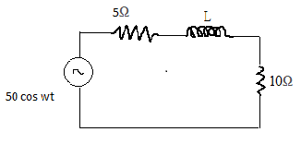 | [3M]
3. | Two 2H inductance coils are connected in series and also magnetically coupled to each other the coefficient of coupling is 0.1, then find out the equivalent inductance of the combination. | [3M]
4. | State Milliman’s theorem. | [3M]
5. | A two port network is described by V₁= 50I₁+ 20I₂ and V₂= 30I₁+10I₂ then calculate its Y- parameters. | [3M]
6. | Explain the significance of RLC series transient. | [2M]
7. | What is the power factor in the series RLC circuit at resonance? What is the reason for that? | [2M]
8. | Two coupled coils with self inductances of 1H and 2H are connected in series aiding. The Resulting inductance L_{eq} is 4H. Find the coefficient of coupling between them | [2M]
9. | State super position theorem. | [2M]
10. | What is the transient free condition in case of A.C circuits? | [2M]
Part – B Max.Marks:50
ANSWER ANY FIVE QUESTIONS. EACH QUESTION CARRIES 10 MARKS.

11. | a) | Explain the Mesh analysis used in the circuit analysis. What is the significance of Super mesh? | [4M]
 | b) | Using nodal analysis, Determine the Voltage across the 2Ω resistor shown in figure.  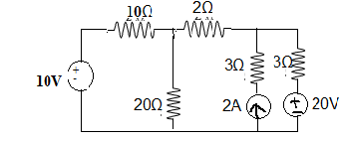 | [6M]
12. | a) | Explain the concept of Average value and RMS value. | [4M]
 | b) | An RLC series circuit with a resistance of 10Ω, inductance of 0.2H and a capacitance of 40µF is applied with a 100V supply at variable frequency. Find the following with respect to the series resonant circuit  (i)Frequency at which resonance takes place (ii)Current  (iii)Power (iv)Power factor  (v)Quality factor (vi)Half power frequencies. | [6M]
13. | a) | Determine the equivalent L_{eq} in the circuit shown in Figure  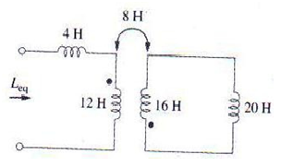 | [6M]
 | b) | If the two identical coils have an equivalent inductance of 0.08H in series aiding and 0.035H in series opposing, what are the values of L_{1,} L_{2,} M and K? | [4M]
14. | a) | Using method of superposition, determine the current through the 5kΩ resistors for the circuit in figure  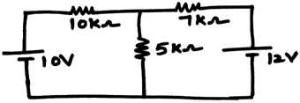 | [8M]
 | b) | State Thevenin’s theorem. | [2M]
15. | a) | Express Z- parameters in terms of ABCD-parameters. | [5M]
 | b) | Obtain the Z–parameters used for series connected two port network. | [5M]
16. | a) | Considering the following circuit determine the V_{c}(t) and i_{c}(t) for t≥0.  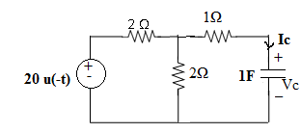 | [7M]
 | b) | Analyze the DC response for RL circuits | [3M]
17. | a) | Distinguish between potential difference and electromotive force. | [3M]
 | b) | A series RLC circuit has R=80Ω, L=100µH, C=0.3µF. Find the resonant frequency and current at resonance if the supply voltage is 10V. | [4M]
 | c) | Draw the impedance triangle of series R-L and R-C circuits. | [3M]
18. | a) | Find the Thevenins equivalent with respect to terminals a-b in the circuit shown in Figure  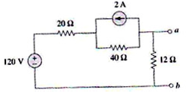 | [4M]
 | b) | List h-parameters in terms of Z-parameters. | [4M]
 | c) | Explain the significance of Transients | [2M]
-- 00 -- 00 –

